SIMATS ENGINEERING
ASSESSMENT TOOL 4

COURSE NAME: Artificial Intelligence COURSE CODE: CSA17

COURSE OUTCOME COVERED

CO2: Experiment search and game-solving techniques such as Greedy Search, A*, CSP, Minimax, and Alpha-Beta pruning with heuristic functions for solving complex AI problems efficiently. (BL3)

Assessment Tool Weightage: 40%

Duration: 1 Hour
QUESTIONS: 3 Total Marks:30

Annexure A

sDry Run Evaluation

Code of Conduct:

I CH Venkata Navaneeth (192311211) certify that this submission is my original work and that I have adhered to the guidelines specified for this assessment.
I understand that any violation of academic integrity rules will result in disciplinary action.

Signature of the student: 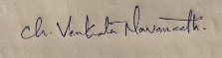

Annexure A

Dry Run Evaluation
1. Question 1 – Breadth-First Search (BFS)
Consider the following graph: A
/ \
B C
/ \ / \
D E F G
Task: Starting from node A, perform a Breadth-First Search (BFS). Complete the following table.
Iteration | Queue | Visited Node
1
2
3
4
5
6
7
Questions:
- Write the BFS traversal order.
- Show the queue contents after each iteration.

Given Graph
A
/ \
B C
/ \ / \
D E F G

BFS Algorithm
- Start from A.
- Visit nodes level by level.
- Use a Queue (FIFO).

BFS Execution
Iteration | Queue (After Expansion) | Visited Node
1 | B, C | A
2 | C, D, E | B
3 | D, E, F, G | C
4 | E, F, G | D
5 | F, G | E
6 | G | F
7 | Empty | G

BFS Traversal Order
A → B → C → D → E → F → G

Queue Contents Step-by-Step
Initial Queue:
[A]

Visit A
Queue: [B, C]

Visit B
Queue: [C, D, E]

Visit C
Queue: [D, E, F, G]

Visit D
Queue: [E, F, G]

Visit E
Queue: [F, G]

Visit F
Queue: [G]

Visit G
Queue: []

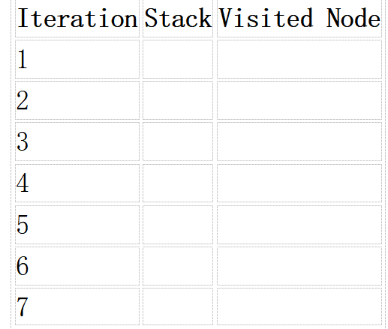
2. Depth-First Search (DFS) Using the same graph,
A
/ \
B C
/ \ / \
D E F G
Perform Depth-First Search (DFS) starting from A.
Given Graph
A
/ \
B C
/ \ / \
D E F G

DFS Traversal
Start at A.
Go to the leftmost child first.
Traversal Order:
A → B → D → E → C → F → G

DFS Execution Table
Iteration | Stack (Top → Right) | Visited Node
1 | C, B | A
2 | C, E, D | B
3 | C, E | D
4 | C | E
5 | G, F | C
6 | G | F
7 | Empty | G

Stack Contents Step-by-Step
Initial Stack:
[A]

Visit A
Push C, B
Stack: [C, B]

Visit B
Push E, D
Stack: [C, E, D]

Visit D
Stack: [C, E]

Visit E
Stack: [C]

Visit C
Push G, F
Stack: [G, F]

Visit F
Stack: [G]

Visit G
Stack: []

DFS Traversal Order
A → B → D → E → C → F → G
Complete Table
Iteration | Stack | Visited Node
1 | C, B | A
2 | C, E, D | B
3 | C, E | D
4 | C | E
5 | G, F | C
6 | G | F
7 | Empty | G
DFS Traversal: A → B → D → E → C → F → G

- Initial State :
1 3 6
5 0 2
4 7 8

Goal State :
1 2 3
4 5 6
7 8 0

Task
Trace Breadth-First Search (BFS) until the goal state is reached.
Fill in the table.
Iteration | Current State | Queue Before Expansion | Queue After Expansion
1
2
3
4
5

Questions
- Which node is expanded in each iteration?
- How many states are generated in total?
- Write the complete solution path from the initial state to the goal state.
- Why does BFS always find the shortest solution in an unweighted 8-puzzle problem?

1 3 6
5 0 2
4 7 8
Goal State
1 2 3
4 5 6
7 8 0
BFS Trace Table
Iteration | Current State | Queue Before Expansion | Queue After Expansion
1 | 1 3 6 / 5 0 2 / 4 7 8 | [136/502/478] | [106/532/478, 136/052/478, 136/520/478, 136/572/408]
2 | 1 0 6 / 5 3 2 / 4 7 8 | [106/532/478, 136/052/478, 136/520/478, 136/572/408] | [136/052/478, 136/520/478, 136/572/408, 016/532/478, 160/532/478]
3 | 1 3 6 / 0 5 2 / 4 7 8 | [136/052/478, 136/520/478, 136/572/408, 016/532/478, 160/532/478] | [136/520/478, 136/572/408, 016/532/478, 160/532/478, 036/152/478, 136/452/078]
4 | 1 3 6 / 5 2 0 / 4 7 8 | [136/520/478, 136/572/408, 016/532/478, 160/532/478, 036/152/478, 136/452/078] | [136/572/408, 016/532/478, 160/532/478, 036/152/478, 136/452/078, 130/526/478, 136/528/470]
5 | 1 3 6 / 5 7 2 / 4 0 8 | [136/572/408, 016/532/478, 160/532/478, 036/152/478, 136/452/078, 130/526/478, 136/528/470] | [016/532/478, 160/532/478, 036/152/478, 136/452/078, 130/526/478, 136/528/470, 136/572/048, 136/572/480]
Answers
1. Expanded node in each iteration:
- 136/502/478
- 106/532/478
- 136/052/478
- 136/520/478
- 136/572/408
2. Total states generated (after 5 iterations): 13
3. Complete solution path: Goal state is not reached within 5 iterations, so the complete solution path cannot be obtained from the given table.
4. Why does BFS always find the shortest solution?
Because BFS explores nodes level by level, and in the 8-puzzle each move has an equal cost (1). Therefore, the first time the goal is reached, it is guaranteed to be the shortest path.

RUBRICS FOR CALCULATION

Criteria | Weightage (%) | Level 4 – Exemplary (4) | Level 3 – Proficient (3) | Level 2 – Developing (2) | Level 1 – Beginning (1)
Understanding of Search Problem | 20 | Clearly understands the search problem, initial state, goal state, and search strategy. | Understands the problem with minor misunderstandings. | Demonstrates partial understanding of the search problem. | Shows little or no understanding of the search problem.
State Expansion and Dry Run Execution | 30 | Correctly traces every iteration, expands nodes accurately, and maintains the Queue/Stack/Priority Queue without errors. | Performs most iterations correctly with minor mistakes in state expansion or data structure updates. | Performs only some iterations correctly; several errors in tracing or node expansion. | Unable to correctly perform the dry run or expand states.
Application of Search Algorithm | 20 | Applies the selected algorithm (BFS/DFS/UCS) correctly, following all algorithmic rules. | Applies the algorithm correctly with a few procedural errors. | Applies only basic algorithm steps with noticeable mistakes. | Fails to apply the correct search algorithm.
Accuracy of Solution Path | 20 | Identifies the correct traversal order/solution path and goal state with proper justification. | Solution path is mostly correct with minor errors. | Partially correct solution path; goal may not be reached correctly. | Incorrect or incomplete solution path.
Presentation and Logical Reasoning | 10 | Queue/Stack/Priority Queue updates, state diagrams, and explanations are neat, organized, and logically presented. | Presentation is clear with minor organizational issues. | Limited explanation and organization; reasoning is partially clear. | Poor presentation with unclear or missing reasoning.

